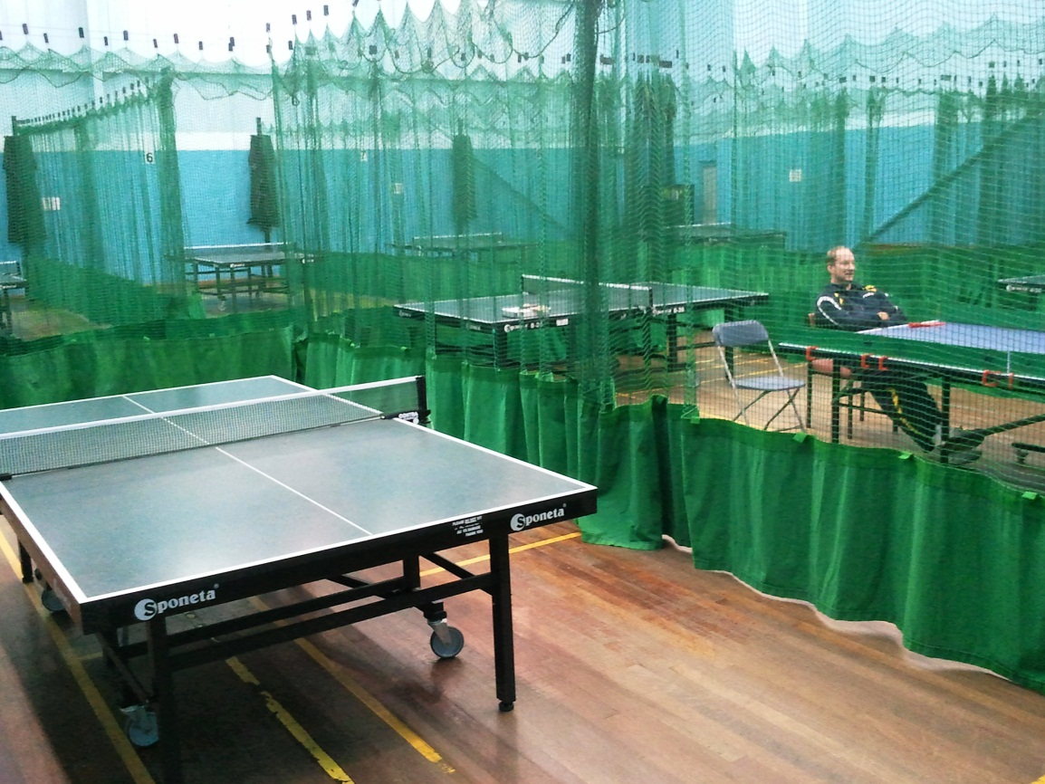
JANUARY 2012
Hyndburn Table Tennis Centre, ACCRINGTON BB5 4EP
Ramsbottom
Table
Tennis
Academy
Saturday Table Tennis!!

Hyndburn Table Tennis Centre is part of the main Leisure Centre at Hyndburn; it takes 25 minutes at the most from the Centre of Bury, up the M65. Some of you have been before.
It’s a dedicated Table Tennis Centre and we have found out that it is available for us on Saturday afternoons; £3 each. Unfortunately we haven’t been able to secure a second night at Castle Leisure in Bury so this would be the next best thing.
In the main photo you can see the hall and all 8 tables have nets around because they play League matches there as well. You will see Dave sat at one of the tables and Mandy and Mick Moir are on the other two. As well as being 6 times Bury Men’s Champion Mick also works for the ETTA and is based at Hyndburn. Mick was demonstrating an alternative to TT using the red ‘paddles’ that you can see on the tables. Mandy, Dave, Mick and me had a game of ‘doubles’ which was great fun. Dependent on numbers interested this would be available to us on Saturdays as well.
There would also be opportunities of playing juniors that Mick coaches and could even arrange friendly matches.
So what we need is to know who would be interested in coming. It is available EVERY Saturday afternoon providing we had a
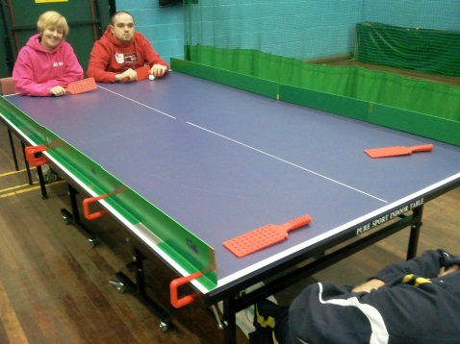
regular number attending. We would ensure that at least one of the Committee would be there and could obviously help with transport.
We view the session as a practice not coaching but we would be on hand to ‘organize’ the session. Parents are welcome to play as well. So PLEASE email Keith if you are interested and replies no later than Saturday 4th February. keithrw19@gmail.com

