Ramsbottom Table

Tennis Academy
www.tabletennisacademy.co.uk | June 2010

SECOND YEAR SUCCESS STORY
W

here has all the time gone! Twelve months ago we were struggling for space on four tables at Ramsbottom Civic Hall. Now we have ample space, eight tables, more coaches, a National table tennis award, Clubmark accreditation and increased numbers attending to list our main achievements in this time. A number of you have been introduced to competitive table tennis for the first time and have had really good results. We had a squad of six players in the ETTA National Cadet League for the first time and everyone who played improved their game significantly. The Bury and District Table Tennis League allowed ten or so of our players in to the junior championship and everyone performed really well. Special mention should go to Callum Stott who got to the final and played fantastic TT only to lose to an older and more experienced junior.

INTRODUCTION OF THE BUTTERFLY SKILLS
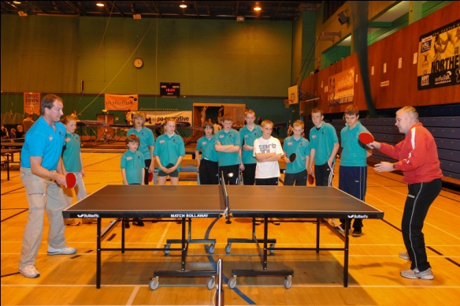
At the start of the last session we moved some of you between the two sessions according to your ability. The first session is now geared to ‘beginners’ and the second to ‘intermediate/advanced’ players. We also started on the ‘Butterfly Skills Awards’ programme which has clear content for each session dealing with all the different strokes and skills in the game.
You all now have individual assessment sheets and theses are updated as you attain each of the criteria set out in the Awards Programme. Once you have completed the section that the coaches have assigned to you will receive a Butterfly Skills Certificate for that section of the programme. Everyone is working through the Bronze category at the moment at ‘starter’, ‘improver’ or ‘advanced’, whichever section the coaches are assessing you at. As the Bronze category is completed then we will move to the Silver then Gold and then onto the Olympics…we hope!!
The photo above was taken at a recent coaching session where Graham and Dave are demonstrating a specific stroke that you are about to practice.

New Club Shirts
In the last Newsletter we said that we would be changing our club shirts to table tennis specific shirts. During the summer break we will be contacting everyone to see what size shirts you will need. The only problem in changing to these shirts is that they don’t do child sizes. XXSmall is the smallest which is similar to aged 9 to 10 child. We do want everyone to have club shirts so the only solution we can think of is that we keep the existing shirts for the younger ones in the club.
We did get some funding for the new shirts but it won’t cover the full cost. As soon as have the costs we will let you know.

Club Membership
In the last Newsletter we also talked about paying in advance for the coaching rather than each week you come. We have had no objections from you to this and have therefore decided to start the membership fee from Friday 3rd September; the first Friday back after our summer break.
Because there are 16 weeks in this session we have decided to split payment so you will only pay for 8 weeks at a time. The cost for this session will be £20 (£2.50 x 8 weeks) and would ask that everyone brings this with you at the first session. The second payment will be due on the 22nd October. In January 2011 we will have two more 12 week sessions but again we will just ask for payment for 8 weeks at a time. We will remind you when the membership fees are due.
There are many benefits to this arrangement and here are the important ones.
- We want everyone to feel that they are MEMBERS of our Academy. Paying weekly does not give that feeling of ‘belonging’ to the Academy.
- We can plan our sessions better because we will know who is coming week to week.
- Knowing how many are coming to the sessions ensures that we deliver the quality coaching sessions that we want and to give everyone value for money.
- We want everyone to come EVERY week to improve their TT skills. There should be a greater incentive for everyone to come if they have paid for all of the sessions.
- Less hassle for you and us by paying five times a year rather than every week.

Two more important things we should mention. The Leisure Centre increase their fees every January. In January 2010 we were able to keep the weekly £2.50 unchanged because we had funding for the hire of the hall. The Leisure Centre however did increase their prices. From January 2011 therefore we will be increasing the weekly fee to £3.
As we have said earlier we want everyone to come every week so they can improve their skills. There won’t be any refunds of the membership fee which is no different to any club that you pay membership to.

2010-11- OUR 3rd SEASON

The Club Committee are planning for the future already. We are the sole table tennis coaching club in the area and have formed a strong partnership with the Bury Sports Development Team and the schools Partnership Development Manager. We have had a meeting to discuss the possibility of forming ‘satellite’ clubs within some schools in Bury. Plans are in the early stages but it is an exciting development that could add strength to our clubs structure. During the summer break we hope to have more information and will keep you posted. We are also working on ideas about how we want our club to develop in the future.

and finally…
There are opportunities of playing through our summer break for those who are interested. A table can be hired at Castle Leisure Centre and you play in one of the squash courts. Quite a number have been to Hyndburn TT Centre just through Accrington. Contact Bryan if you are interested.
Just to point out that these are not organised by us.
If you decide not to play then enjoy your break and we look forward to seeing you on FRIDAY 3rd SEPTEMBER.

