june newsletter
www.tabletennisacademy.co.uk June 2009
CIVIC HALL UPDATE
The Civic Hall exterior work is behind schedule and should have been finished by the end of May. Internal work has still to be done and could cause disruption when it starts. We intend to complete our 3rd session with two final coaching nights at the CASTLE LEISURE CENTRE in Bury using the Main Hall. For those who don’t know where it is the full address; Bolton Street, Bury.BL9 0EZ.
We hope that the last 5 weeks of this session will be different, interesting and of benefit to all.

END OF SESSION CHANGES/DATES
Friday 12 June | Normal Programme.6pm &7pm
Friday 19 June | 1) One session at Civic Hall. 630pm to 745pm  2) 8 selected players to Hyndburn for Challenge Match. 630pm to9pm
Friday 26 June | LAST SESSIONS AT CIVIC HALL. 6pm &7pm
Saturday  27 June | Champions Challenge at Wright Robinson Sports College. 2/4 selected players representing Bury.
Friday 3 July | Castle Leisure Centre Main Hall.2 Sessions at 6pm and 7pm. All players to be assessed by Adam.  FREE PARKING after 6pm.
Saturday 4 July | Party Time at Bryans. For those interested contact Bryan.
Friday 10 July | FINAL NIGHT. Club Tournament at Castle Leisure Centre. 1 Session. 6pm to 8pm.

Some of the prize winners at the Sports Fun Night
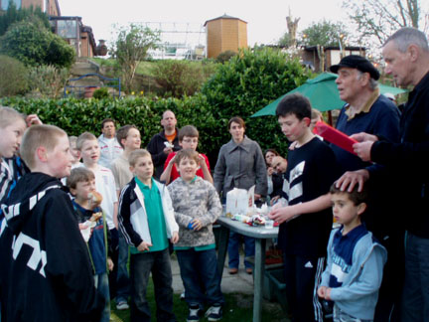

Inside This Issue
1 | Civic Hall Update
1 | End of Session Changes/Dates
2 | Future Plans for September, Coaching Programme,
2 | 2009/10 Season, Our first year,

FUTURE PLANS FOR SEPTEMBER
We are exploring the possibility of new premises which can house up to 8 tables. The CASTLE LEISURE CENTRE may be one venue. Sessions will still be on Fridays at the same times.
It is hoped to have a table for parents to use/practice on…for a small charge!
******WATCH THIS SPACE!!******

COACHING
The coaching programme will continue but there will be an equal emphasis on practice match play and ladder competitions.
Possible options for match play are being explored for next season.

1 | Club Ladder System
2 | Junior League play centred at Hyndburn
3 | Cadets/Junior Tournament.  (3 Sundays only)
4 | A junior team in the Bury TT League
5 | Play at the Bury League Tournament in April 2010
6 | Places in Ramsbottom TT Club Teams

2009/10 Season
Coaching will start on FRIDAY 4th SEPTEMBER.
All relevant details will be in our July/August Newsletter including our new venue.

OUR FIRST YEAR

September 2008 | Opened expecting 8 on the first night and 24 turned up!
December 2008 | Created links with Hyndburn TT Centre and held our first session there.  End of year fun night was a huge success.
January 2009 | Received our AWARDS FOR ALL lottery grant for new tables and equipment.  Adam receives his UKCC level 1 coaching certificate.  Website launched.
February 2009 | Launched our new club tee shirt.  Sponsorship from RBS.  Accepted on the ETTA PremierClub accreditation scheme.
April 2009 | Mandy, Graham and Michael complete their UKCC level 1 coaching course.  Brian Ingham already a long time ETTA level 4 coach.
May 2009 | Introduced new ETTA PremierClub Membership forms.  Produced club handbook.  More funding applied for.

We are looking forward to a second year of progress and expansion. This could not have been possible without all our willing volunteers. ++++++++A big thank you to you all++++++++

Bryan Keith Adam Paul Brian



