
We seem to have settled in very well at ‘Castle’ in our new larger venue. There is a lot more space and a lot more noise because of the other activities going on but it is far better for us to be in a dedicated sports complex.
We now have 3 UKCC Level 1 coaches and 4 coach assistants who are taking their Level 1 coaching qualification. Our 3 coaches are soon to be taking Level 2 which is two full weekends for the course plus lots of ‘homework’. We are very fortunate to have this many. We know of lots of other clubs who struggle on with one coach.
When numbers permit the space parents/volunteers table has been well used and we will continue to offer that subject to the numbers attending.
After the first week one of the boys attending lost his jacket which we were sorry to hear about. This wasn’t brought to our attention until the following week so there was little we could do. On the wall next to the door to the main hall there is a ‘disclaimer’ notice by the Leisure Centre about not being responsible for any loss or damage. As you will have seen there is a lot of through traffic past us to other badminton courts and the trampolines so the only safe way to look after possessions is to use the ‘dry side’ lockers provided by the Leisure Centre. We will do our best to safe guard any belongings but we equally can’t be held responsible if they go missing.
We have notice that the wall where the seating is stored is ‘eating’ our TT balls! When they ‘whizz’ in there it is almost impossible to get them back. Please do your best to look after the balls you are playing with and return them to the bag on the table where Keith sits. We have lost easily around 40 balls since being at Castle and there is a cost to replace them.

Castle Leisure Centre
Though we haven’t been able to enter our own Academy team into the Bury League this season there is limited opportunity for Bryan to get some matches for a few of you with Ramsbottom Town TTC. So far Callum Stott and Nicholas Kroll have played. Callum has won 5 out of 6 and Nicholas 5 out of 12. Well done to Callum and Nicholas. It’s not the winning at this stage its getting experience and Bryan will do his best to give others the opportunity.
Inside This Issue
1 Castle Leisure Centre
1 Local League Play
2 Katy Parkers Visit
3 ETTA National Cadet League
4 PremierClub Status Update
4 Club Funding

“We now have 3 Level 1 coaches and 4 coach assistants who are taking their Level 1 coaching qualification.”
Newsletter October 2009

Local League Play
tabletennisacademy.co.uk

Ramsbottom Table Tennis Academy
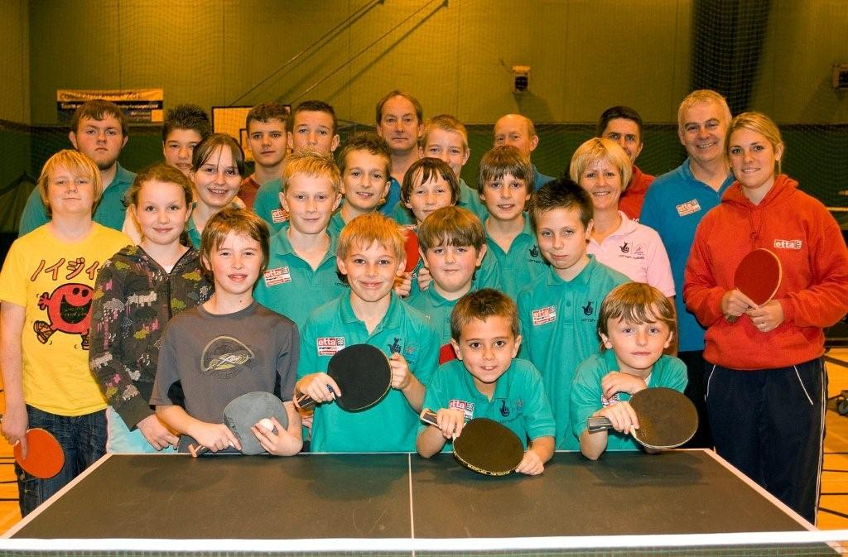
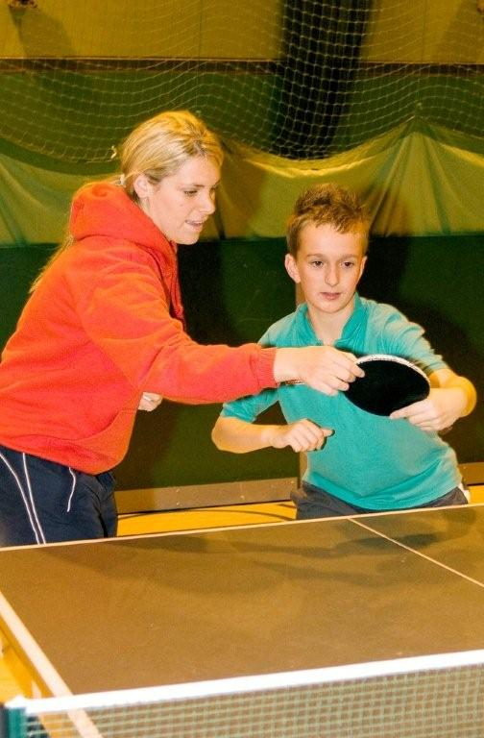
Katy Parker is the ETTA North West Coach and is a very experienced player herself. Katy was the youngest player ever to represent England in the senior team at the 1997 Manchester World Championships at the age of 12! She reached the top in women's table tennis during her teen years, but quit international competition to concentrate on her education.
Katy won national titles at three different junior levels and became England's No.1 and has travelled the world playing table tennis. Her coaching credentials were recognised when in 2008 the English Table Tennis Association voted her Young Coach of the Year.
As most of you saw Katy was very much ‘hands on’ with her coaching during her visit and was of great benefit to the junior players, coaches and volunteers. Katy commented on the number of qualified coaches and coaching assistants the club has. On the night there were 3 qualified coaches and 3 assistants. This is part of the reason why the club to grown so quickly in numbers in the last 12 months.
Katy plans to visit is again early in the New Year.

Katy with everyone who attended on the 9th October
“Katy was the youngest player ever to represent England in the senior team at the 1997 Manchester World Championships at the age of 12!”

Katy Parkers Visit
Katy with Nick Kroll
There are four fixture dates; 18th October and 22nd November this year, 31st January and 28th March next year. The North West fixtures are being played at the Halton Table Tennis Centre in Widnes. This new table tennis facility was opened at the Halton Rugby Stadium in 1999.
Sport England Lottery grant provided £2.31 million pounds towards the new West Stand, which was for community use and for the Halton Regional Table Tennis Centre.
This prestigious National Cadet League is designed for younger players in his/her developing years. The qualification is for anyone born in 1995 or later.
Our aim is for our players to gain experience in competitive play and unlike the Local League opportunities everyone is the same or similar age.
At the first match played on Sunday 18th October 2009 Nicholas Kroll, Tom Warburton, David Headley and Reece Mitchell took part. Play started around 1000 though our players arrived at 0900 for a good warm up before their matches. The last match finished around 430pm. The format was a team of three. We were allocated a place in the 2nd of 3 divisions. There were 5 other teams to play on the day so we rotated the players in the team to give everyone as equal a chance to play in the matches.
 | Played | Won
Nicholas | 8 | 4
David | 8 | 4
Reece | 8 | 3
Tom | 6 | 3

With these results we won 2 matches, lost 2 and drew one.
A great achievement by all four players.
The next match takes place on SUNDAY 22nd November again at Halton and supporters are welcome to attend.

ETTA National Cadet League
“Last year 222 teams played in 16 centres over 4 days.”

We started the accreditation process late last year and our ‘stumbling block’ was the number of hours of table tennis our club can deliver. Local League play and the ETTA National Cadet League contributes to the hours we deliver, now they have started, we qualify in all categories in the PremierClub accreditation and have been notified by the ETTA that our certificate is ‘on its way’ to us. Big Celebrations all round when we get it.

PremierClub status update

Club Funding
We applied to SPORT ENGLAND earlier in the year for a grant to help towards the cost of our coaches and also our club shirts and we are delighted to say we got the grant accepted last month.
Most of you have got a shirt and we have ordered some more for the newer members. It’s good to see you all wearing them when you come on a Friday.
Because we have moved from Ramsbottom to Bury we deliberated over our club name. It’s not straightforward to change the name so we decided to add to the name on the back of the shirts ‘at Castle Leisure’. Below is a sample of how it will look.
Last Year Mandy got some funding from her employers, RBS via their Community Funding and applied this year and we have been successful in getting the funding again. Many thanks to Mandy.





