**W**ell you might not think much has happened in the last sixteen weeks but you would be mistaken!

First of all we have had quite a number of new faces join us which is great and we hope all of our new members are enjoying themselves and continue to improve their ‘TT’ skills. Some of our regulars have improved and moved to the second session at 7pm which leaves room for quite a few more new members in our 6pm beginners’ session. So we would ask you all again to ‘spread the word’ amongst your family and friends to see if you can bring anyone along who wants to play TT. *A box of 3 star TT balls to anyone who introduces someone new to the Academy!!*

We have had introduced quite a number of you to competitive play for the first time either at the ***ETTA Cadet League*** or playing in the local ***Bury Table Tennis League***. We have had very encouraging results in the Cadet League, and have tried to share out equally those playing half a day and a full day. Parents have been very supportive and with the 3rd of 4 rounds being played on Sunday 8th January we are straight back into playing after the Christmas break.

Because we have more members involved in competitive play we wanted to see what we could do in the way of some extra coaching/practice. We have been fortunate to get some extra funding for additional coaching on Saturday’s or Sunday’s for those who play in the Cadet and Bury League. We will be contacting everyone concerned as soon as Mandy and Dave have sorted out their 2012 diaries.

Practice and play on the robot has gone down very well with everyone and we know you all would like more time on it. We will do our best to provide this.

The end of year ***Christmas Tournament*** went very well and everyone seemed to enjoy themselves, parents included. We had the added bonus of a couple of ‘celebrities’. Sam and Emma Jeffries’ Dad, ***Graham*** is a three time past Bury League Men’s Champion and he managed to get himself to the final of the Parents Tournament where he faced ***Brian Kean,*** who is the ETTA North West Regional Coach and a past Scottish International. Many thanks to Graham, Brian, all of the parents and YOU, who all helped to make the night such a success.

# Photos from the Christmas Tournament

# LAST SIXTEEN WEEKS REVIEW

**Ramsbottom**

**Table Tennis Academy**

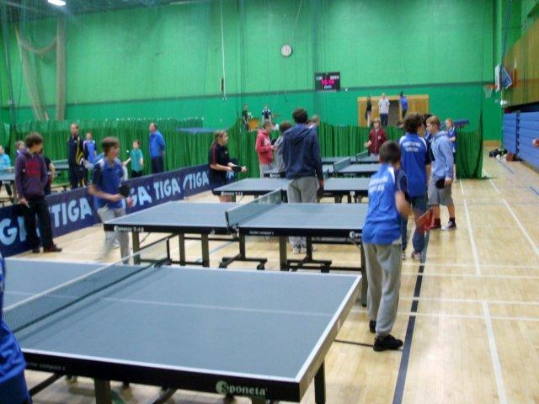

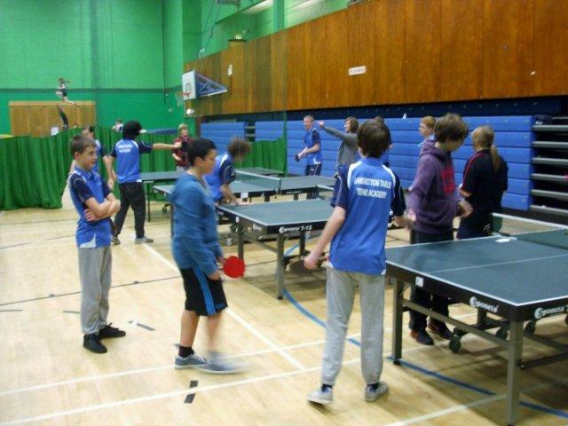

*December 2011*

www.tabletennisacademy.co.uk



# Second Robot

When we got our ***Sport England*** Grant earlier in the year it was for two robots. We have one as you know and we do intend to introduce the second one when you numbers increase a bit more.

At the moment we can manage our session with one but as soon as our numbers attending get to around 36+ in both sessions then we will introduce the second robot.

We explain to every new member that if you come to us for 4 weeks or more that you should have your own bat and an Academy Shirt. We provide both of these.

The reason for your own bat is that we ensure that it’s the correct one for your level of play. Any old bat won’t do. You could be severely disadvantaged if you play with an old bat that someone may have given you. Without getting too technical the type of rubbers on you bat have a big influence on how you play. So we always provide everyone with the same ‘beginners’ bat with a cover that costs just £15. You can pay a lot more for bats but for beginners it just isn’t necessary.

As far as our Academy shirts are concerned we supply table tennis specific shirts made by STIGA a well know table tennis equipment manufacturer. These are also £15. We do like our members to have an identity with the Academy plus it is the right shirt for you to play in. We do ask that all of our members come to the coaching sessions in these shirts AND suitable trainers. Thanks.

If we happen to have missed supplying anyone with the bat or shirt, please contact Keith and he will get them sorted for you. We only charge you what we pay for them. The shirts actually retail at £25.99 so we have a good deal on them.

# Playing equipment and Shirts

Our first week back on Friday 6th January Mandy and Dave will be doing assessments of everyone to get an update of your coaching progress so far. The ***Butterfly Skills*** programme will restart the following week and, using the records of what you attained last year at Bronze or Silver levels and their assessment the previous week they will set the level which you should continue at.

For those of you who are new to us and haven’t started the ***Butterfly Skills,*** then Mandy and Dave our coaches will start you at the beginning so you don’t miss anything.

The ***Butterfly Skills*** will run through to around Easter. Good Friday is the 6th April so there will be no coaching then and we have also found out that there is a big boxing event being held in the main hall so in preparation for that there will be no coaching on Friday 2nd March but for those interested we will arrange a match up at Hyndburn, Accrington as we have done in the past. Please make a note of these dates and we will also remind you nearer the time.

Sam with others watching his Dad Graham in the Parents Final

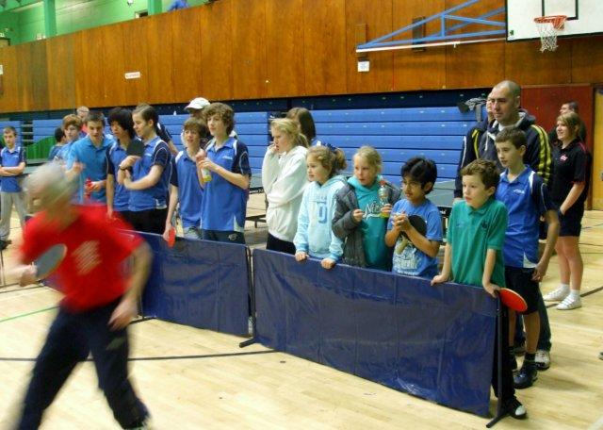

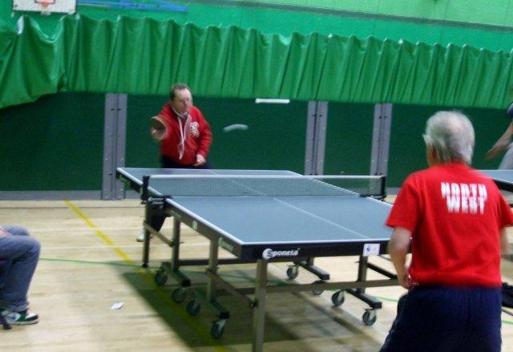

Graham and Brian fight it out in the parents final

# What’s happening in 2012

…Butterfly Skills programme will restart the following week…

The 8 weekly subscriptions are due again when you start back on ***6th January.*** It’s £24 as usual.

This just leaves space enough to wish everyone a Happy Christmas and New Year and look forward to seeing everyone on the 6th January.

**Bryan, Keith and the Committee**

# …and finally

# A Parents’ table on Fridays

We have had a ‘loose’ arrangement in the past that parents can have a game of TT whist they wait if there is a table free. What we have decided to do is where numbers attending permit; we will try to keep a table free in each session so parents can have a game. So if you do want to play please wait for the session to start to give and Mandy and Dave a chance to sort the numbers attending on their tables and see Keith for a loan bat. We would ask that you please pay £1 for the use.

# New Parent Representative

We are pleased to let you know that ***ERIC SMYTHE,*** Granddad of Amelia Behrens, who comes to the second session, has joined our Committee as Parent Representative. Eric has been a great help to us in helping setting up and operating the robot. He has also very kindly done some running repairs to our tables to keep them in great condition. Thanks to Eric for taking up some of his time in helping with the running of the Academy. Eric will liaise between the Parents’ and the Committee.

7pm Finalists Nick and Tom receive their award from Brian Kean

Amelia and Olivia receive a small prize from Bryan because the two girls play in the Bury League matches

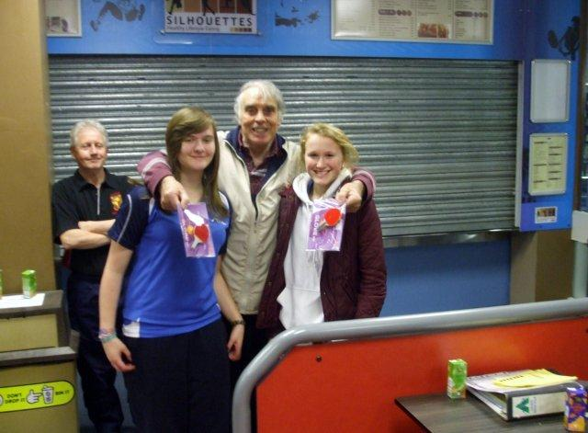

Last summer we asked everyone if you would attend a second night of coaching, say on a Tuesday or Wednesday. There wasn’t sufficient response from you and we suspect our timing was out asking you because summer had started and a lot of you had other interests.

We are still looking at a second night but at the moment the Leisure Centre does not have another night available. Before we speak to the Leisure Centre again we would like to ask you again if you would be interested in attending a second night’s coaching.

We have given thought, especially in view of the success of our Christmas tournament, whether parents would like to be included in the second night so giving them an opportunity to play some table tennis as well.

Please let us know by emailing Keith. Thanks.

# A Second Night?

