Newsletter Number 6
may 2009
may newsletter

www.tabletennisacademy.co.uk

EVERYONE WINS AT THE FAMILY SPORTS NIGHT
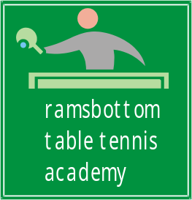



CONTENTS
- Sports night report
- Replacement Membership Forms
- Venue Update
- Coaching Programme
- Champions Challenge
- Whit Holidays
- Committee Meeting Update
- Our COLD coach

Yes, everyone was a winner at our first Sports ‘fun’ Night held in Bryan’s garden. The weather was kind to us until later in the evening when it went quite cold. The activities included a soccer challenge, putting, skipping, throwing a ball and of course table tennis. There was plenty of competition between everyone which was good to see and there were some impressive individual results and everyone went away with a prize. The main aim was to have a different night than the coaching but there was an opportunity of having a raffle to raise some funds. We decided to have this night at fairly short notice so we weren’t sure whether we were going to have to pay for the room hire at Ramsbottom. As it turned out we didn’t so the £55 raised on the night was gratefully received. Thanks to everyone who generously bought tickets and to those of you who donated prizes.

Replacement Membership forms

A couple of weeks ago a replacement Membership Form was emailed to everyone. They replace the ones supplied by ‘Bury Metro’ and were in the ETTA PremierClub pack that we received. It asks for the usual, name address, phone number and ‘OCCUPATION’!! If you haven’t filled one in please ignore that box but let me have the completed for as soon as possible. For those of you who are under 16 there is section for parents to sign; in particular a consent for us to take photographs. Please be assured that photographs will not be taken without asking first and they will only be for club use.

Venue Update

The external work, we understand is behind schedule and was due to complete at the end of May. It appears to be a couple of weeks behind which, at the moment does not affect us. There is then internal work to be done which WILL be disruptive but we are hopeful to complete our current session by the end of June.

Coaching Programme
We are planning to continue with the coaching at the Civic Hall until Friday 26th June. Because of the uncertainty of the Hall being available to us after this date we plan to end this current session with two weeks of assessments and some competitions on the 3rd and 10th of July.

During June we are planning to have matches against other junior coaching groups.
We are planning to have these last two sessions at CASTLE LESIURE CENTRE in Bury Town Centre where we have been offered space in the main hall.

Champions Challenge Update
Following on from the email sent on the 8th May to those eligible to take part. We are still waiting to hear from the Sports Development Team at Castle Leisure Centre regarding the numbers who are to be assessed. As soon as we hear from them we will contact all concerned.

*************** Whit Holidays ****************
We need to know if you are not able to come to the Friday night coaching on 29th May.
Depending on the numbers we may just have one
Session at 630pm to 745pm. Please let Keith know ASAP if
you are not coming on this date. Thanks.
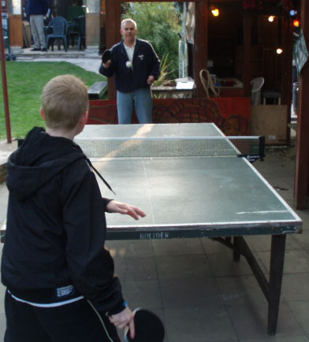

Graham at the Table Tennis Challenge during the Sports Night at ‘Bryans Place’.

Update from our last Committee Meeting
PremierClub Accreditation
We are almost there with our application. The only item missing now is our ability to ‘deliver’ the playing programme that the ETTA stipulate for this accreditation. We may not be able to complete this until after our summer break.

Part of the playing programme is a Junior Umpire Award which Adam mentioned last week. It entails answering 10 multiple choice questions about TT and then to be able to demonstrate that you can ‘Umpire two best of three matches, showing overall control and accuracy when announcing the score.’
We will be incorporating information about the questions during the next few sessions.

Health and Safety is an important feature of the accreditation and we will have to carry out, by law, one test evacuation per year. We will carry this out soon.
New Club Handbooks
We have produced a club handbook from a template supplied to us from the ETTA PremierClub pack and will be handing them out next week. Please make sure you show them to your parents. It has all the information about our club and more.

Future Funding/Grants
You will be pleased to know that we are not ‘broke’ yet! Keith met with the Bury 3rd Sector Development Agency last week to look for funding for our room hire, coaching fees and even our club shirts. You will be pleased to know that we were able to find organisations that we can apply to for this funding and we will be looking to do that over the coming months.

Competitive TT 2009/10
1. There may be a junior Leage in East Lancs for all ages- Friday nights.
2. National Cadet/Junior Leagues. Played in the North West on 4 Sundays throughout the season.
3. Ther possibility of playing in the Bury TT League- mid week play.
Please let Keith know if you are interested in any of these.

Hope you
enjoyed the read

Bryan

Keith

Adam

Paul

Brian

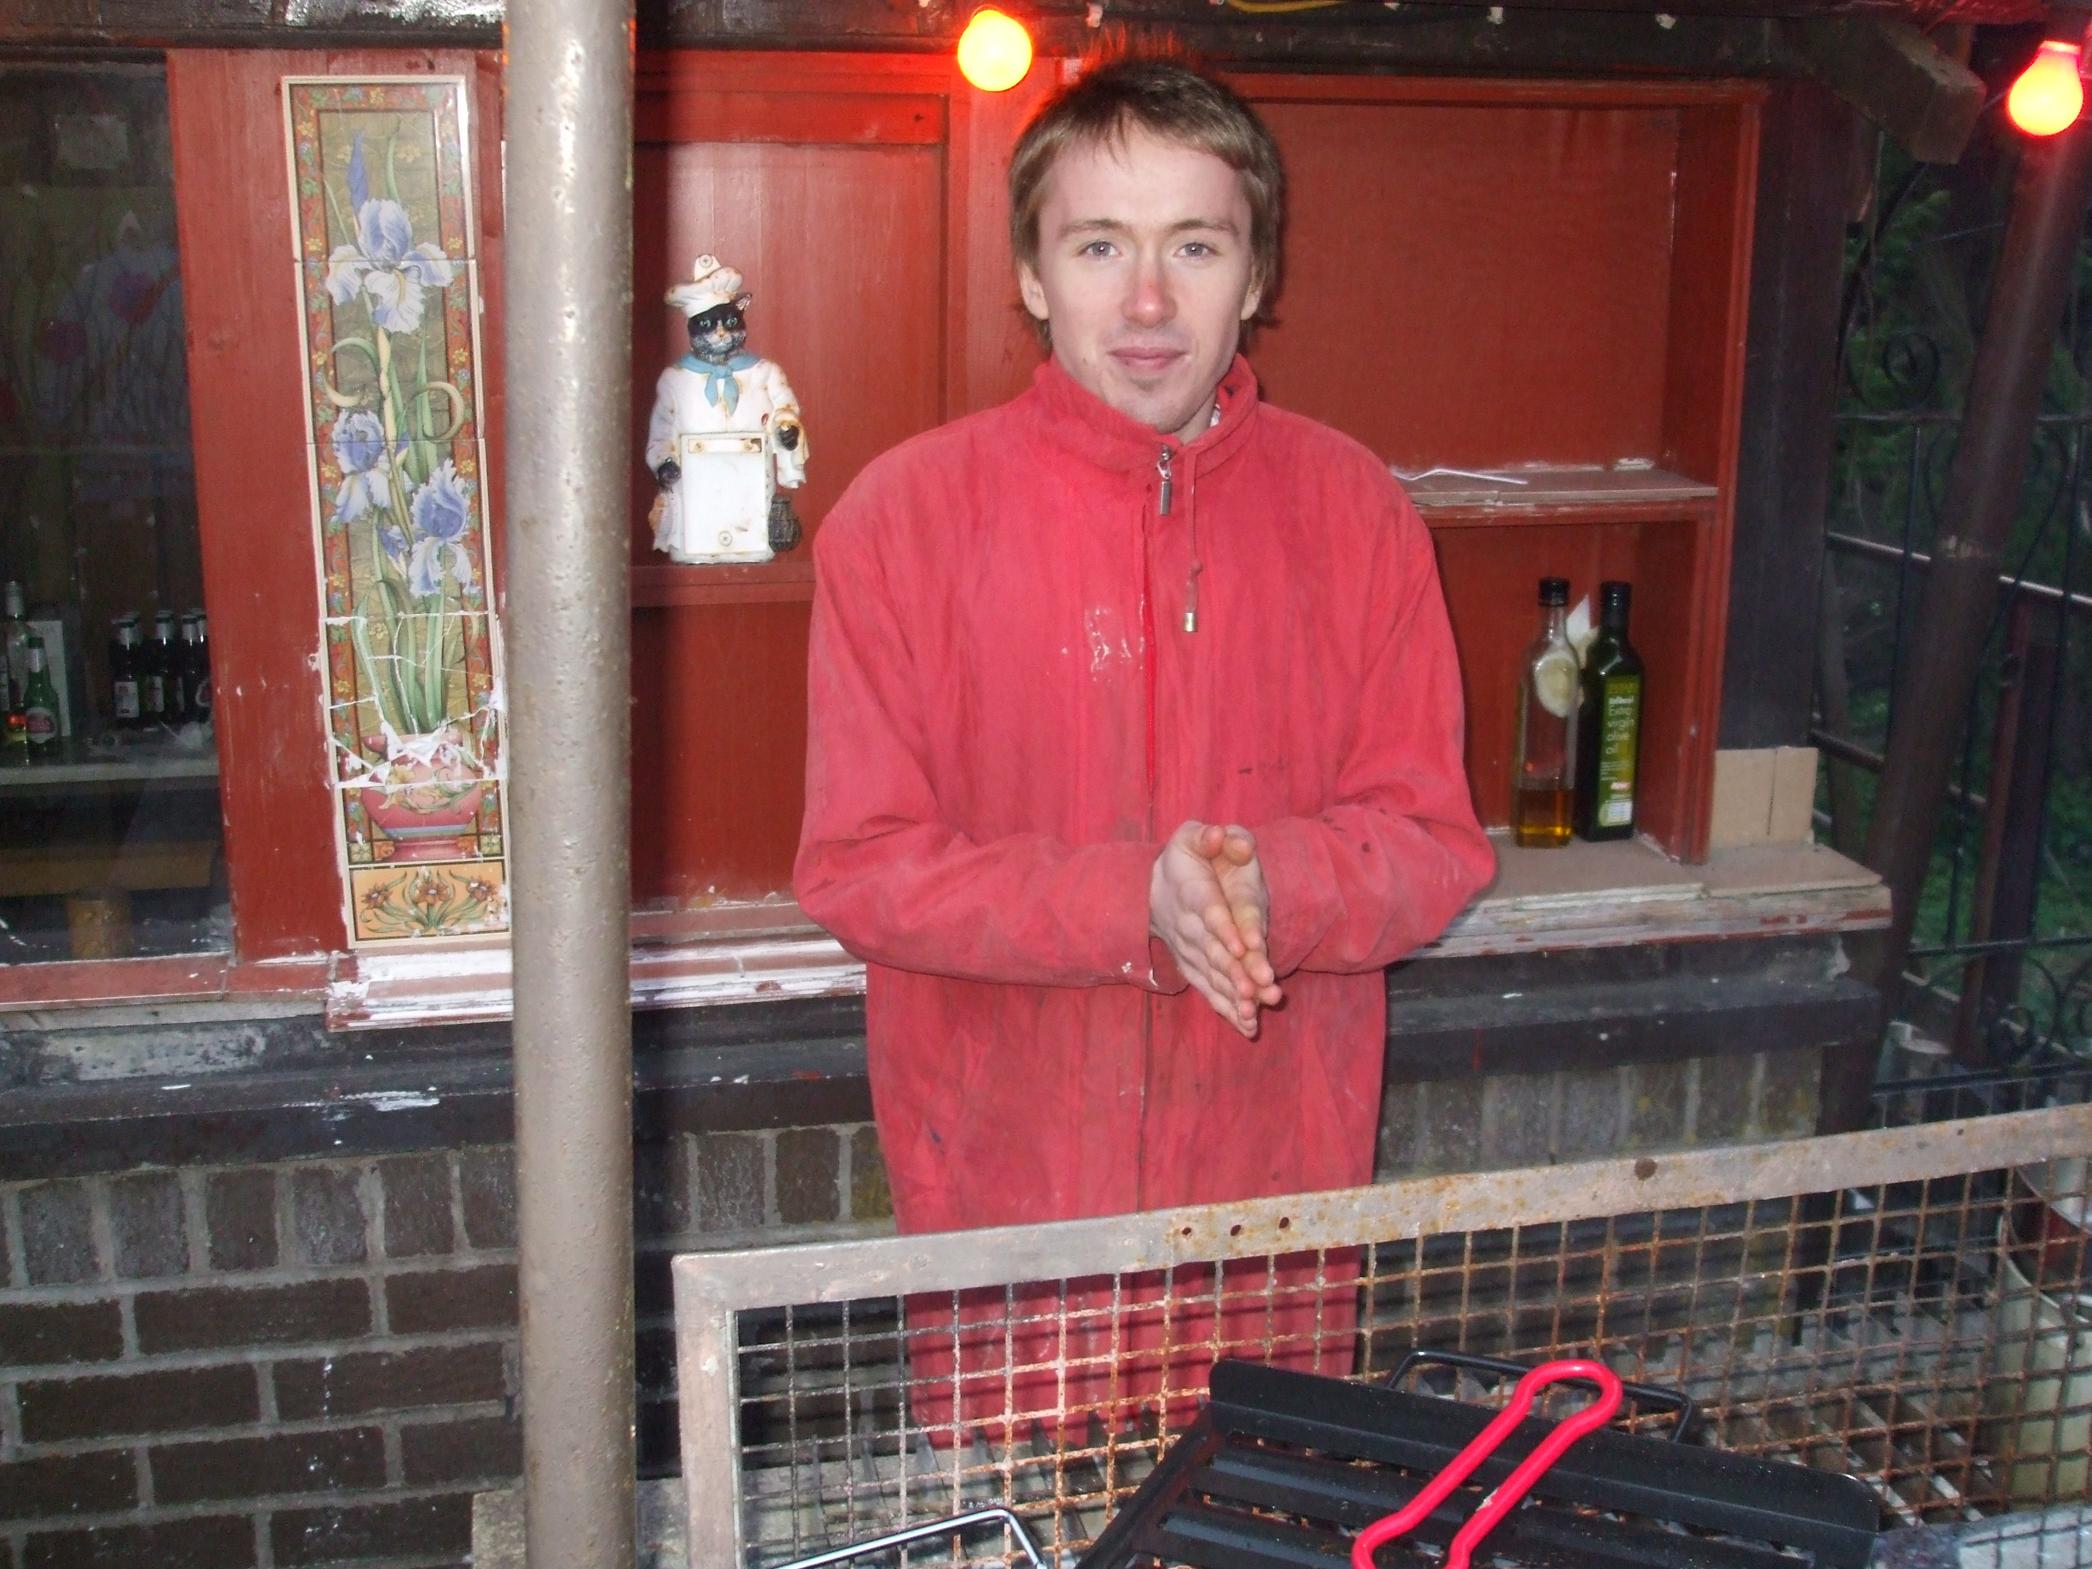

Your VERY COLD coach at the
Sports Fun Night

